April 14, 2023

To: Local Church Clergy

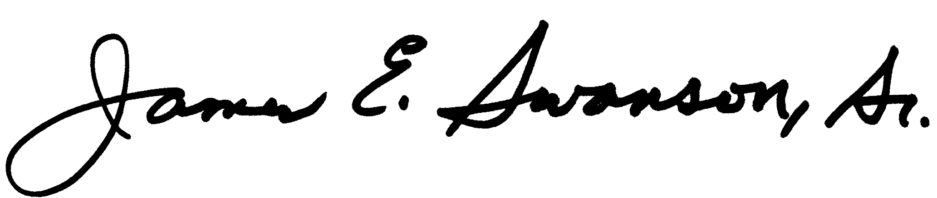
From: David Stotts, CPA Conference Treasurer

Greetings All:

Thank you for your GENEROSITY as evidenced by your church’s enclosed first quarter mission share report. Thank You for honoring your covenant to support your district and conference’s mission and ministry for 2023.

As of March 31, we are at an average collection rate for conference mission shares of 15.62% compared to 15.92% last year. Please review your church’s apportioned mission share giving. If you find any errors, please be in contact with Laura Rollins at 769-243-7024.

Another Glory Sighting is the response to the recent tornadoes Mississippi experienced. UMCOR immediately got the initial grant of $10,000 within 5 days. Checks have poured in from individuals and churches to help provide recovery for the people who lost their homes and to help with the losses experienced by the churches. Our own PACT insurance adjusters were on the ground and in the disaster area within the first 24 hours following the tornadoes. Within a week, we had over $175,000 of insurance money headed to the churches.

Please watch the Circuit Rider monthly. There is important financial information there for you and the church. Remember that your stats for 2022 should have already been completed. By annual conference action in 2022, the audits of the local churches are due by 6-30-2023.

Below you will find the mission of the annual conference. Please share this often with your church so that they know why we as Mississippi United Methodist do what we do and why we do it in a connectional way.

We are proud to be your Administry Department. If there is anyway, we can resource you, please contact us!

The Mississippi Annual Conference—empowered by love, generosity, justice and apprenticeship—forms spiritual leaders, faith communities and connections so more disciples of Jesus Christ transform the world.

